**Experiment No. 10**

**Object:**

1. To create sub interfaces in Router using CLI mode.
2. Inter VLAN Routing (Encapsulation Technique)

**Date:** April 7, 2018

# Configuration Figure:

# 

# Coding: *On ROUTER*

--- System Configuration Dialog ---

Continue with configuration dialog? [yes/no]: n

Press RETURN to get started!

Router>en

Router#conf t

Enter configuration commands, one per line. End with CNTL/Z.

Router(config)#

Router(config)#interface gig 0/1

Router(config-if)#ip address 192.168.1.1 255.255.255.0

Router(config-if)#no shutdown

Router(config-if)#

%LINK-5-CHANGED: Interface GigabitEthernet0/1, changed state to up

%LINEPROTO-5-UPDOWN: Line protocol on Interface GigabitEthernet0/1, changed state to up

Router(config-if)#ex

Router(config)#

Router(config)#interface gig 0/1.1

Router(config-subif)#

%LINK-5-CHANGED: Interface GigabitEthernet0/1.1, changed state to up

%LINEPROTO-5-UPDOWN: Line protocol on Interface GigabitEthernet0/1.1, changed state to up

Router(config-subif)#en

Router(config-subif)#encapsulation dot1Q 10

Router(config-subif)#ip address 192.168.10.1 255.255.255.0

Router(config-subif)#no shutdown

Router(config-subif)#ex

Router(config)#interface gig 0/1.2

Router(config-subif)#

%LINK-5-CHANGED: Interface GigabitEthernet0/1.2, changed state to up

%LINEPROTO-5-UPDOWN: Line protocol on Interface GigabitEthernet0/1.2, changed state to up

Router(config-subif)#encapsulation dot1Q 20

Router(config-subif)#ip address 192.168.20.1 255.255.255.0

Router(config-subif)#no shutdown

Router(config-subif)#ex

Router(config)#ex

Router#

%SYS-5-CONFIG_I: Configured from console by console

Router#ex

Router con0 is now available

Press RETURN to get started.

Router>

# Coding: *On SWITCH*

Switch>en

Switch#conf t

Enter configuration commands, one per line. End with CNTL/Z.

Switch(config)#vlan 10

Switch(config-vlan)#ex

Switch(config)#vlan 20

Switch(config-vlan)#ex

Switch(config)#in

Switch(config)#interface gig 0/1

Switch(config-if)#switchport mode trunk

Switch(config-if)#

%LINEPROTO-5-UPDOWN: Line protocol on Interface GigabitEthernet0/1, changed state to down

%LINEPROTO-5-UPDOWN: Line protocol on Interface GigabitEthernet0/1, changed state to up

Switch(config-if)#ex

Switch(config)#interface fa 0/1

Switch(config-if)#switchport access vlan 10

Switch(config-if)#no shutdown

Switch(config-if)#ex

Switch(config)#interface fa 0/2

Switch(config-if)#switchport access vlan 20

Switch(config-if)#no shutdown

Switch(config-if)#ex

Switch(config)#

Switch(config)#ex

Switch#

%SYS-5-CONFIG_I: Configured from console by console

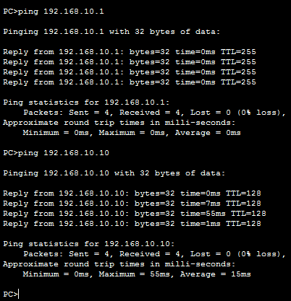

Switch#ex

Switch con0 is now available

Press RETURN to get started

Switch>

# Ping Test:

